**Kollective - Brightcove Integration - User Guide**

**Version: 1.0**

**Table of contents**

1. Introduction

1.1 Purpose

2. Supported User Roles

3. Admin User

3.1. Account Settings

3.2. Manage Users

3.2.1 Create User

3.2.2 Edit User

3.2.3 Delete User

3.3. Video Syndicator

3.3.1 Video List

3.3.2 Video Detail

3.4. Live Events Syndicator

3.4.1 Live Event List

3.4.2 Live Event Detail

3.5. Syndicator Logs

4. User

5. How To Embed Video Asset On The Page

# 1. Introduction

We’ve created an integration to deliver Video On Demand (VOD) and Brightcove Live events to Brightcove players using the Kollective eCDN.

This project consists of two main parts:

* The backend application to users and act as a video syndicator to synchronize videos from Brightcove to Kollective.
* The Kollective plugin for Brightcove players so that players can play back video assets published to Kollective

## 1.1 Purpose

This document will guide use of the backend application and instruct you on embedding the player on the page.

# 2. Supported User Roles

The backend application supports two different user roles as listed below:

* Admin role: Admin users can create other admin users/normal users, access to the company settings, the syndicator tool and check the synchronization logs.
* User role: These users can access the syndicator tool and check the synchronization logs, but cannot edit company settings.

# 3. Admin User

Admin User can access the Users management and create/edit/delete users under the current account

## 3.1. Account Settings

* Login with Admin account.
* Click on “Settings” from the left menu.
* Allow updating information for the company’s account.
* Admin can select the option “Allow Automatic Synchronization” to allow the synchronization job to run automatically at the configurable time interval:
  + Enter a time interval for the job to run, for example: run job every 1 hour.
  + Select time for the job to run for the first time.
  + Enter the Max Videos To Synchronize each time the job runs.
  + You will see the Next Invocation time after saving the setting.
  + You can click on the “Run Job Now” button to run the job immediately.
* Click the Update button to save the settings.

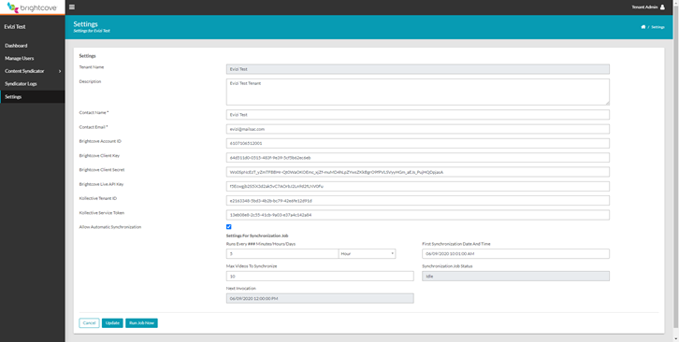

## 3.2. Manage Users

* Login with Admin account
* Click on “Manage Users” from the left menu
* Display all users of the company

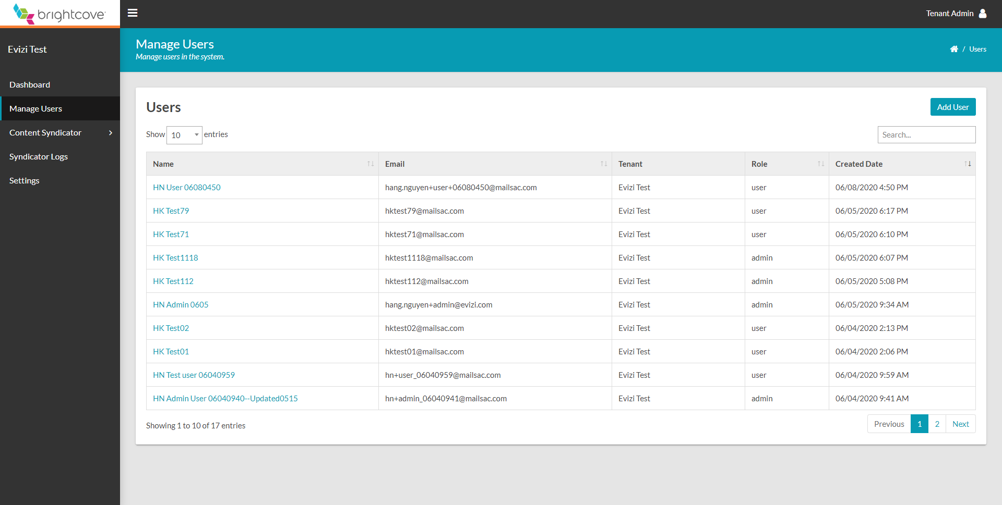

### 3.2.1 Create User

* Click on “Add User” button from Manage Users page
* Create new user with Admin / User role

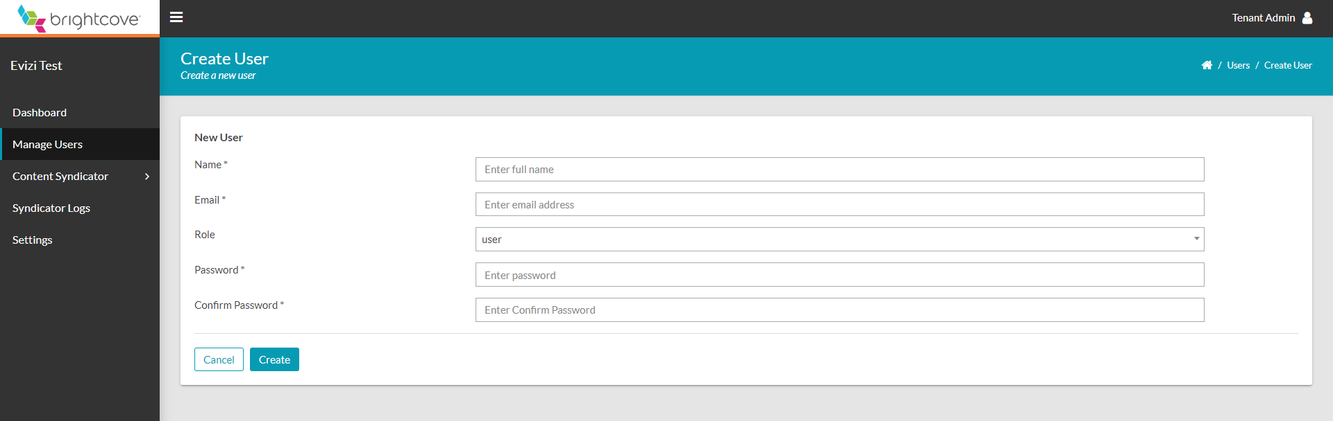

### 3.2.2 Edit User

* Select any user from Users list
* Allow updating any fields except Email

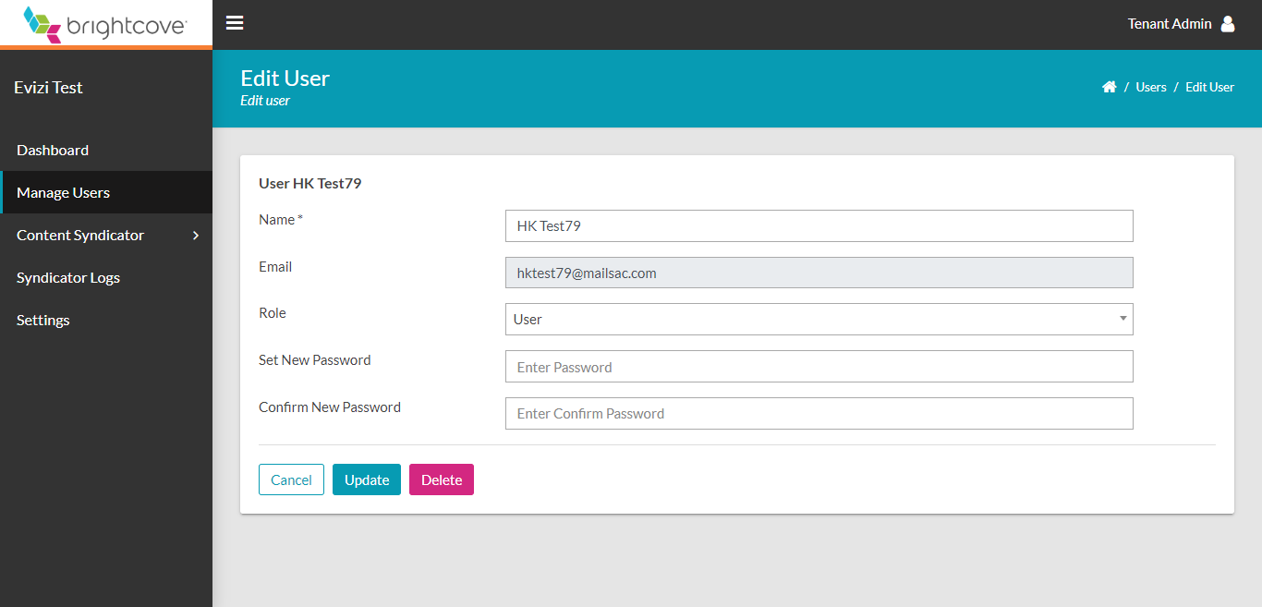

### 3.2.3 Delete User

* Select any user (except logging in user) from Users list
* Click on “Delete” button
* Allow deleting the selected user from the system

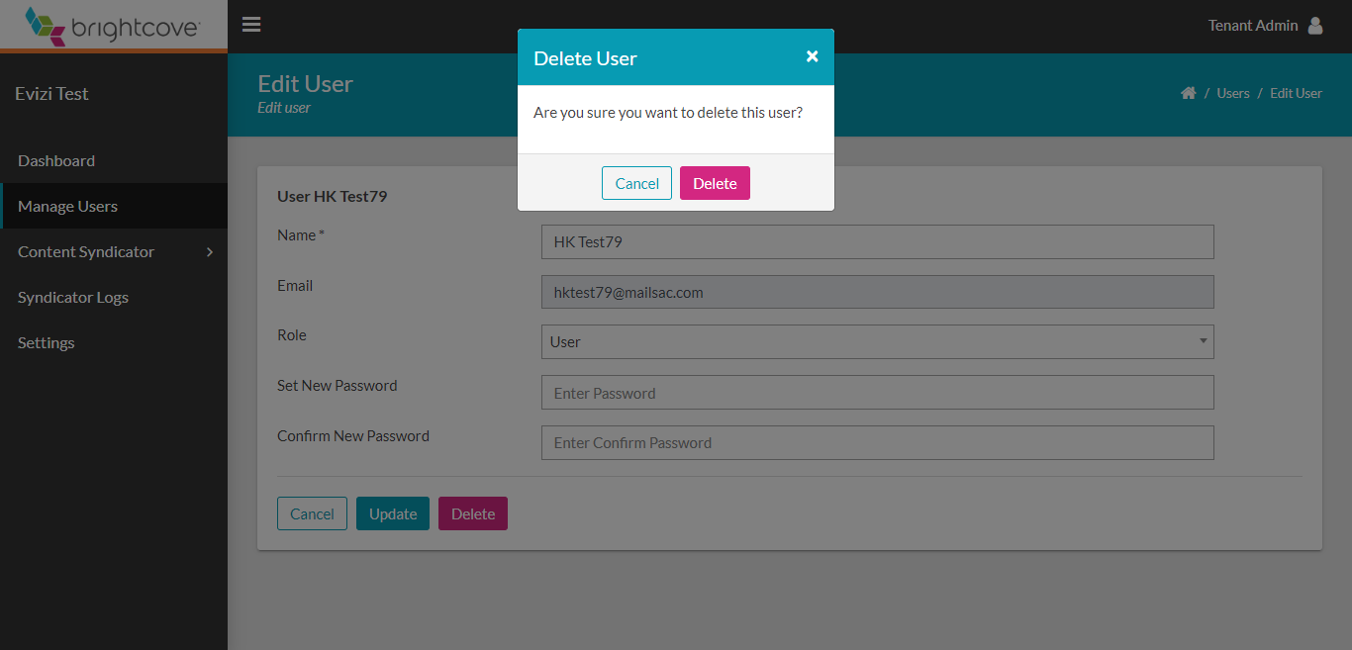

## 3.3. Video Syndicator

Synchronize videos under the current account from Brightcove to Kollective

### 3.3.1 Video List

* Login with Admin account
* Click on “Content Syndicator” from the left menu and select “Videos Syndicator” item
* List all videos in the Video Cloud account with most recent added/updated videos on top
* Allow filtering All/ Synchronized/ Non-Synchronized videos
* Allow selecting videos that have not been synchronized to Kollective or have been synchronized to Kollective with any Failed/ Succeeded status and synchronizing

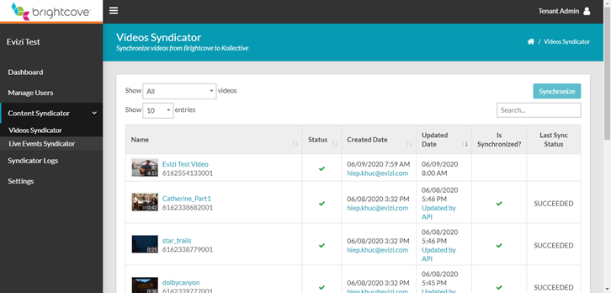

* You can select multiple videos on the list and click the Synchronize button to synchronize the selected videos.

### 3.3.2 Video Detail

* Select any video from Video List
* Display all details of the video from Video Cloud
* Allow synchronizing video from Video Details page
* Update video statuses on Video Details page and on Video Cloud site
* Allow deleting video from Video Details page

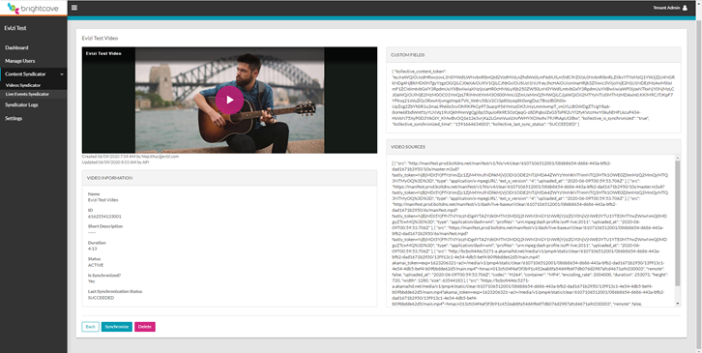

## 3.4. Live Events Syndicator

Synchronize live events under the current account from Brightcove to Kollective

### 3.4.1 Live Event List

* Login with Admin account
* Click on “Content Syndicator” from the left menu and select “Live Events Syndicator” item
* List all live events in the Video Cloud account with “Live” events selected by default
* Allow filtering All/ Live/ Standby/ Completed live events
* Allow selecting live events that have not been synchronized to Kollective or have been synchronized to Kollective with any Failed/ Succeeded status and synchronizing

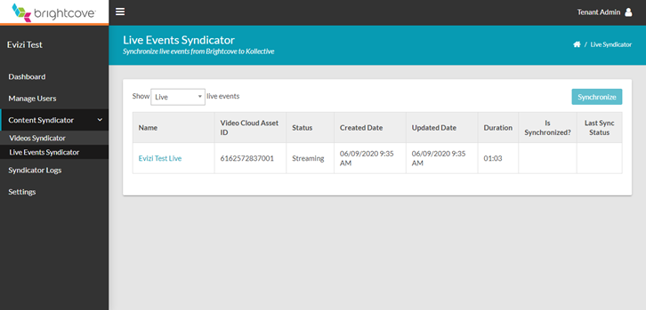

* You can select multiple live events on the list and click the Synchronize button to synchronize the selected events.

### 3.4.2 Live Event Detail

* Select any live event from Live Events List
* Display all details of the live event from Video Cloud
* Allow synchronizing live event from Live Event Details page
* Update live event statuses on Live Event Details page and on Video Cloud site
* Allow deleting live event from Live Event Details page

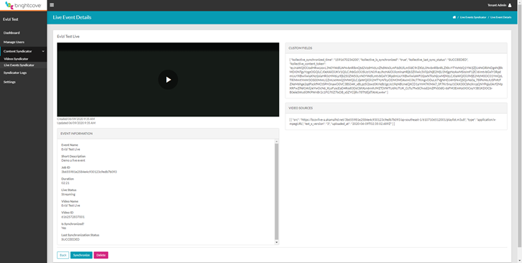

## 3.5. Syndicator Logs

* Login with Admin account
* Click on “Syndicator Logs” from the left menu
* Display all synchronization logs of the current account
* Allow filtering All/ Error/ Info/ Warning logs

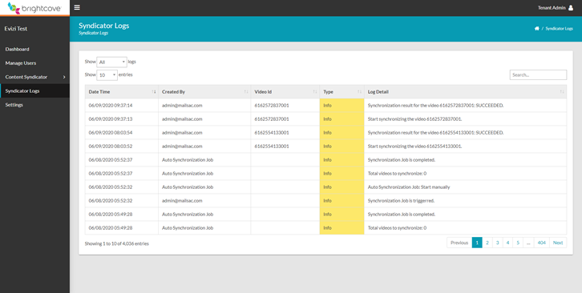

# 4. User

Users with the User role have access to the Video Syndicator, Live Event Syndicator and the Syndicator logs same as the admin user, except these users don’t have access to the Manage Users and Settings pages.

# 5. How To Embed Video Asset On The Page

There is no change on the steps to embed a video on the page using the player that has already been configured to use the Kollective plugin, you can just embed the video with the player normally:

* On the Brightcove Studio Media module, open the video you want to embed, then click the “Publish and Embed…” button.
* Select the player that has already been configured to use the Kollective plugin.
* In the Copy Code section, if you want to embed the video using iframe, then copy the <iframe> code and paste it into your page. The page will look like this:

<!DOCTYPE html>

<html>

<head>

<meta charset="UTF-8" />

<title>Page template - iframe</title>

</head>

<body>

<iframe

src="https://players.brightcove.net/***[BRIGHTCOVE_ACCOUNT_ID]***/***[PLAYER_ID]***_default/index.html?videoId=**[VIDEO_ID]**"

allowfullscreen=""

allow="encrypted-media"

width="960"

height="540"

></iframe>

</body>

</html>

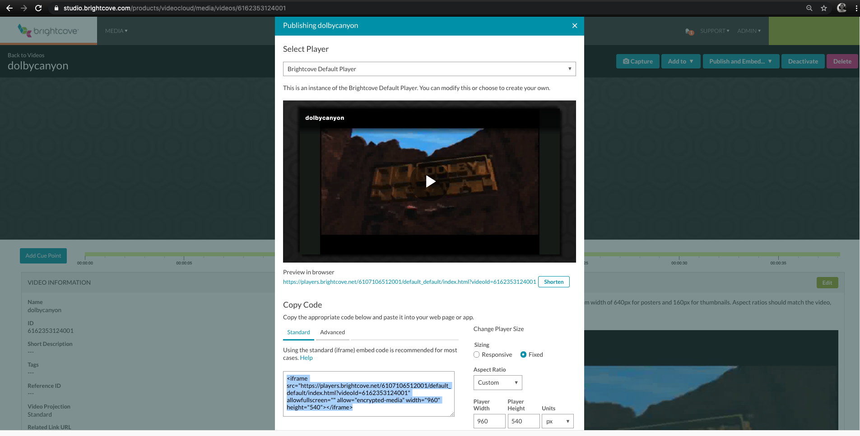

* If you want to embed the video using a more advanced method, copy the advance code and paste it into your page. The page will look like this:

<!DOCTYPE html>

<html>

<head>

<meta charset="UTF-8" />

<title>Page template - Advance</title>

</head>

<body>

<video-js

data-account="***[BRIGHTCOVE_ACCOUNT_ID]***"

data-player="***[PLAYER_ID]***"

data-embed="default"

controls=""

data-video-id="***[VIDEO_ID]***"

data-application-id=""

width="600"

height="338"

>

</video-js>

<script src="//players.brightcove.net/***[BRIGHTCOVE_ACCOUNT_ID]***/***[PLAYER_ID]***_default/index.min.js"></script>

</body>

</html>

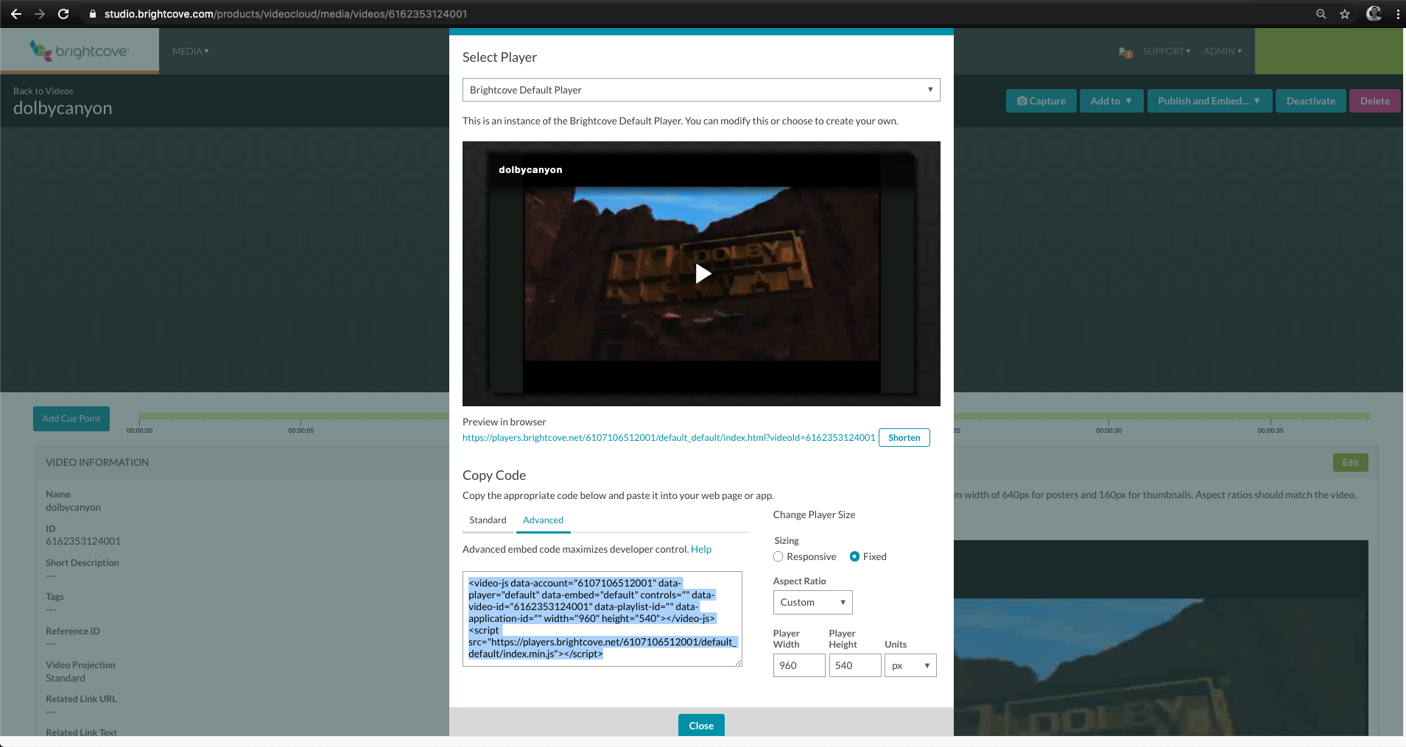

Please note that the domain name where you deployed your pages in needs to be added the Kollective whitelist in order for the Kollective KSDK and the Kollective plugin to work, otherwise you may get the CORS errors and the videos that have been published to Kollective would not be loaded.